PayDollar/PesoPay/SiamPay PayGate
Integration Guide for WooCommerce 2.0

Outline
- Install and configure the plugin on WooCommerce
- Setup datafeed URL on PayDollar/PesoPay/SiamPay

Note: This guide assumes that WordPress and WooCommerce are already installed on your web server.

Install and configure the plugin on WooCommerce

- Upload the paydollar plugin to the wordpress plugins folder (/wordpress/wp-content/plugins/paydollar-payment-gateway-woocommerce/) using an FTP client.
- Login to WordPress Backend
- Go to the plugins section.
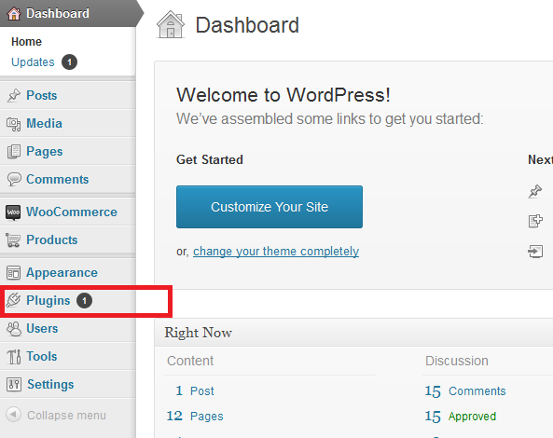
- Find the WooCommerce PayDollar Payment Gatewayand click “Activate”
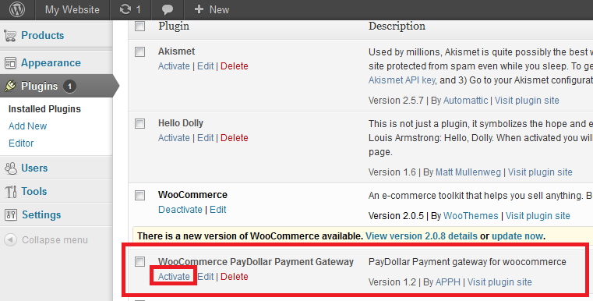

- Go to WooCommerce section > Settings.
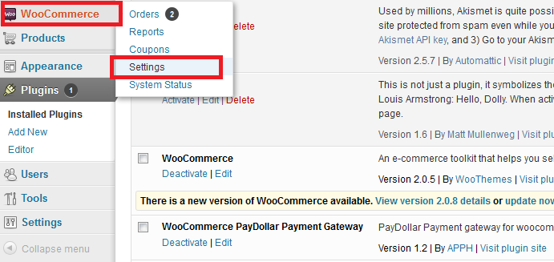
- Go to Payment Gateways Tab.
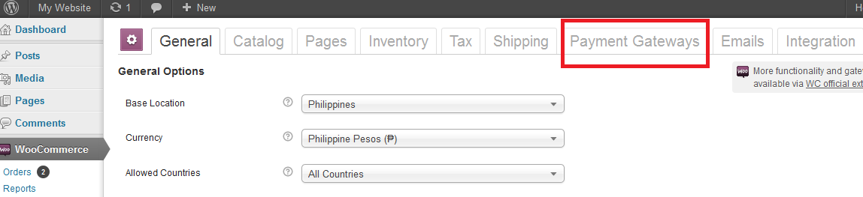
- Go to PayDollar.
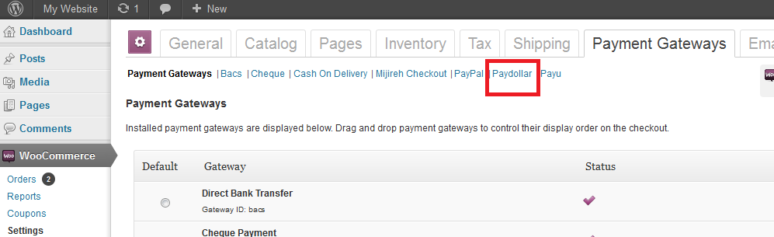

- Set the module configurations
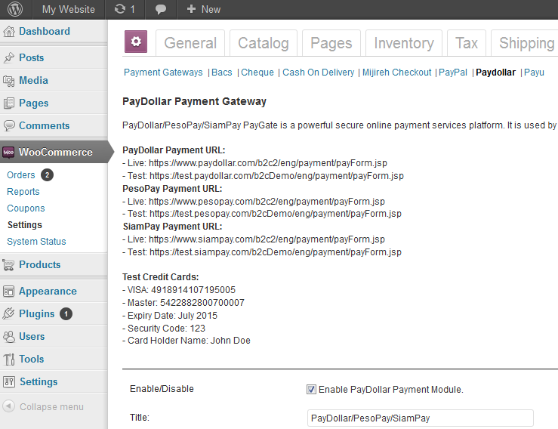
Payment URL: The integration URL to which platform you are to integrate.
Merchant ID: The merchant account id provided by PayDollar/PesoPay/SiamPay
Pay Type: If you prefer N (Sale) or H (Authorize) – Depends on the merchant account
Pay Method: The payment method to display on the payment page. - Depends on the merchant account
“ALL” – All the available payment method
“CC” – Credit Card Payment
“VISA” – Visa Payment
“Master” – MasterCard Payment
“JCB” – JCB Payment
“AMEX” – AMEX Payment
“Diners” – Diners Club Payment
“PPS” – PayDollar PPS Payment
“PAYPAL” – PayPal By PayDollar Payment
“CHINAPAY” – China UnionPay By PayDollar Payment
“ALIPAY” – ALIPAY By PayDollar Payment
“TENPAY” – TENPAY BY PayDollar Payment
“99BILL” – 99BILL BY PayDollar Payment
“MEPS” – MEPS BY PayDollar Payment
“SCB” –SCB (SCB Easy) BY PayDollar Payment
“BPM” –Bill Payment BY PayDollar Payment
“KTB” –Krung thai Bank (KTB Online) BY PayDollar Payment
“UOB” –United Oversea bank BY PayDollar Payment
“KRUNGSRIONLINE” –Bank of Ayudhya (KRUNGSRIONLINE) BY PayDollar Payment
“TMB” –TMB Bank BY PayDollar Payment
“IBANKING” –Bangkok Bank iBanking BY PayDollar Payment
“UPOP” – UPOP BY PayDollar Payment
Language: The language of the payment page
“C” – Traditional Chinese
“E” – English
“X” – Simplified Chinese
“K” – Korean
“J” – Japanese
“T” – Thai
“F” – French
“G” – German
“R” – Russian
“S” – Spanish
Secure Hash Secret: Optional. The secret key for the secure hash functionality – Please check with PayDollar/PesoPay/SiamPay.
Prefix: Optional. Prefix for Order Reference No. (Warning: Do not use a dash "-" because the system uses it as a separator between the prefix and the order reference no.)
Transaction Type: Optional. Suitable transaction type. Goods/ Service Purchase is the Default value if transaction type not provided.
“01” – Goods/ Service Purchase * Default value if threeDSTransType not provided.
“03” – Check Acceptance
“10” – Account Funding
“11” – Quasi-Cash Transaction
“28” – Prepaid Activation and Load
Challenge Preference: Optional. Indicates whether a challenge is requested for the transactions in 3DS2.0. * If “No challenge requested” options are selected, the chargeback liability shift to merchant.
“01” – No preference * Default value if threeDSChallengePreference not provided.
“02” – No challenge requested *
“03” – Challenge requested (Merchant preference)
“04” – Challenge requested (Mandate)
“05” – No challenge requested (transactional risk analysis is already performed) *
“06” – No challenge requested (Data share only)*
“07” – No challenge requested (strong consumer authentication is already performed) *
“08” – No challenge requested (utilise whitelist exemption if no challenge required) *
“09” – Challenge requested (whitelist prompt requested if challenge required)

Setup the Datafeed URL on PayDollar/PesoPay/SiamPay

1. Login to your PayDollar/PesoPay/SiamPay account.
- PayDollar
  - Live: https://www.paydollar.com/b2c2/eng/merchant/index.jsp
  - Test: https://test.paydollar.com/b2cDemo/eng/merchant/index.jsp
- PesoPay
  - Live: https://www.pesopay.com/b2c2/eng/merchant/index.jsp
  - Test: https://test.pesopay.com/b2cDemo/eng/merchant/index.jsp
- SiamPay
  - Live: https://www.siampay.com/b2c2/eng/merchant/index.jsp
  - Test: https://test.siampay.com/b2cDemo/eng/merchant/index.jsp

2. After login, Go to left sidebar on Profile > Profile Settings > Payment Options.
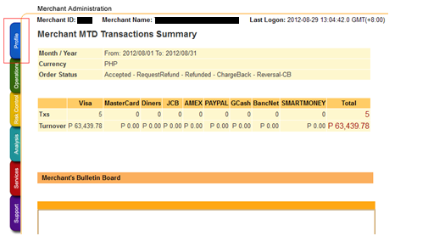

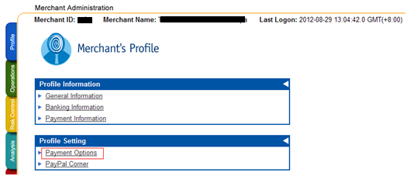
3. Click the “Enable” radio and set the datafeed URL on “Return Value Link” and click the “Update” button.
The datafeed URL should be like this: http://www.yourdomain.com/index.php?wc-api=wc_paydollar
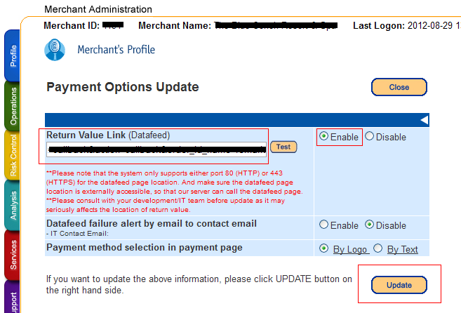

4. On the confirmation page, review your changes then click the “Confirm button”.
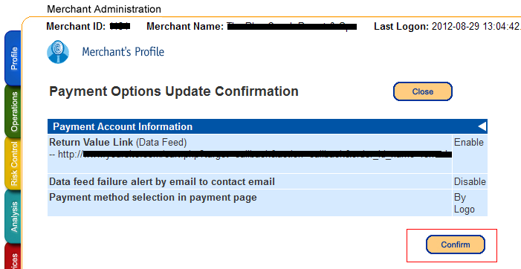

5. The datafeed URL has been set.
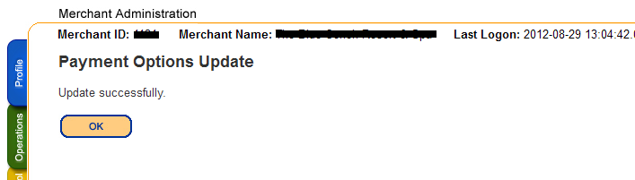

The End

